**Name : Aleshinloye Itunu Adenike**

**Department : Computer Science**

**Course code : Com316 HND1**

**Application number : FPI/HND/2023/0000164**

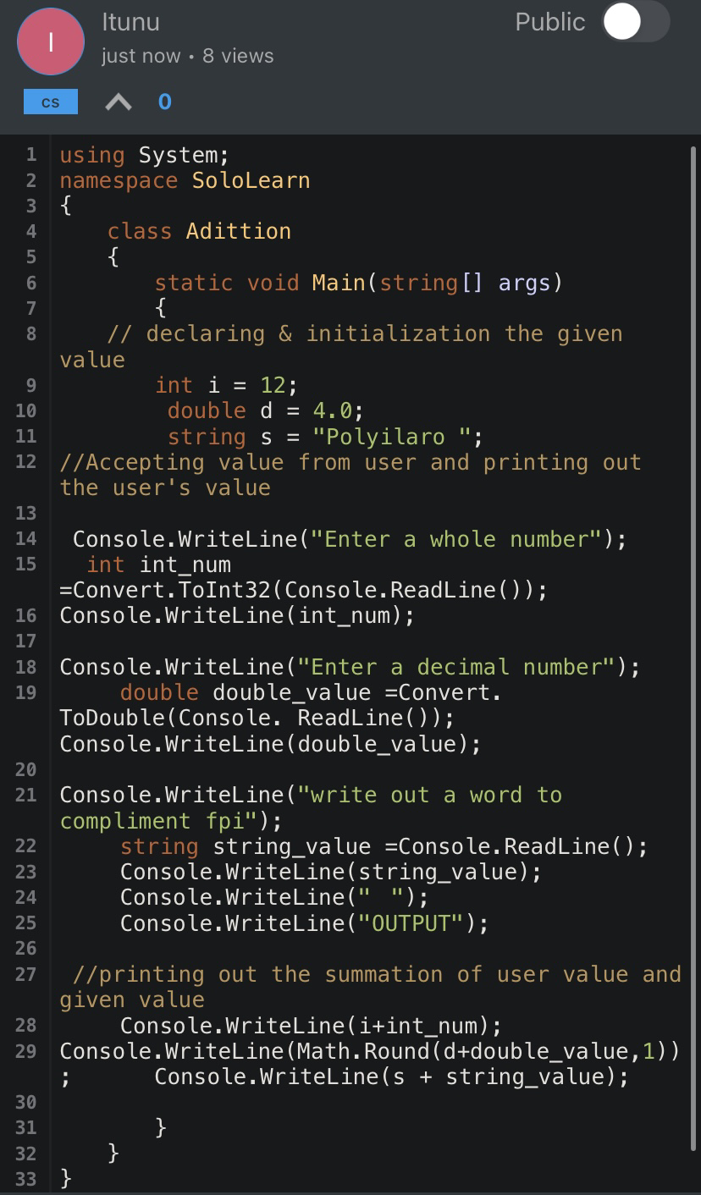

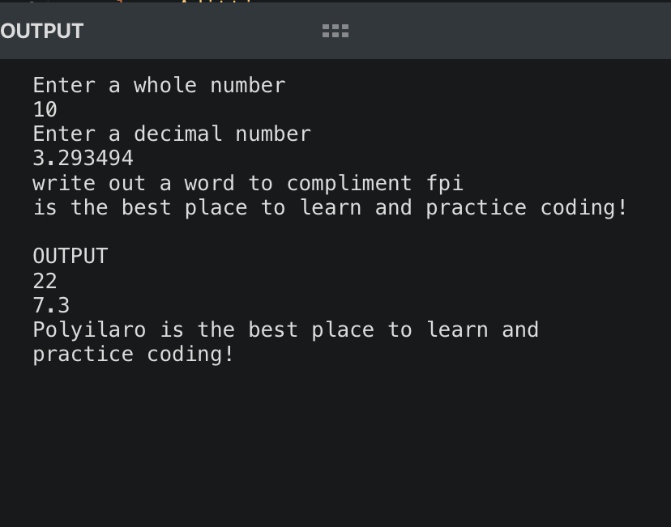

using System;

namespace SoloLearn

{

class Addition

{

static void Main(string[] args)

{

// declaring & initialization the given value

int i = 12;

double d = 4.0;

string s = "Polyilaro ";

//Accepting value from user and printing out the user's value

Console.WriteLine("Enter a whole number");

int int_num =Convert.ToInt32(Console.ReadLine());

Console.WriteLine(int_num);

Console.WriteLine("Enter a decimal number");

double double_value =Convert. ToDouble(Console. ReadLine()); Console.WriteLine(double_value);

Console.WriteLine("write out a word to compliment fpi");

string string_value =Console.ReadLine();

Console.WriteLine(string_value);

Console.WriteLine(" ");

Console.WriteLine("OUTPUT");

//printing out the summation of user value and given value and rounding up the decimal value

Console.WriteLine(i+int_num);

Console.WriteLine(Math.Round(d+double_value,1));

Console.WriteLine(s + string_value);

}

}

}